Build Splitwise Clone — Expense Splitting App (LLD) — Complete Notes

Introduction
Building a Splitwise clone — an expense-sharing application. Common LLD interview question because it involves:
- Group management
- User lifecycle restrictions (can't leave until expenses settled)
- Transaction simplification
- Individual vs group expenses
Core question asked in interviews: How do you prevent a user from leaving a group until all expenses are settled? How do you simplify transactions?

Functional Requirements
# | Requirement
1 | User can join or leave a group
2 | User cannot leave a group until all expenses are settled
3 | User can add an expense in a group (someone paid, amount split among members)
4 | User can settle an expense (e.g., user 2 pays user 1 back) — actual money transfer is via 3rd-party; we only log the settlement transaction
5 | Expenses support multiple splitting strategies: Equal, Percentage, Exact (Unequal)
6 | Users can add individual expenses outside the group (one-on-one)
7 | Notifications sent to all group members whenever an expense is added or settled
8 | Transaction simplification — minimize number of transactions needed to settle a group
Design goal: Split strategies should be extensible (new ones addable without breaking existing code).

Happy Flow Overview
- User opens the Splitwise app
- Sees a list of groups (G1, G2, G3...)
- Each group has multiple members (U1, U2, U3...)
- User can:
  - Add expense in a group
  - Settle expense in a group
  - Interact individually with another user (outside any group)
- On every add/settle action → notification sent to relevant users
- Any time → user can request transaction simplification for a group

Design Approach — Bottom-Up
Start with small independent components, then compose them into the Group:
- Observer (for notifications)
- User (concrete observer)
- Split
- SplitStrategy (Equal / Percentage / Exact)
- SplitFactory
- Expense
- DeptSimplifier
- Group (Observable + main business logic)
- SplitWise (Facade/Manager — orchestrator)

1. Observer Pattern (Notification)

Observer (Abstract)
text
Observer
+ update(message: String)
- Single method update(message) — the Observable calls this on each observer with a notification message

User is the Concrete Observer
- Receives update() calls → prints notification (in real app, this would push to a notification engine → mobile push)

2. User Class

Fields
Field | Type | Purpose
userId | String | Unique ID (e.g., "user1", "user2" or UUID)
name | String | User's name
email | String | Optional; used for display
balances | Map<String, Double> | Other user ID → amount (positive = they owe me, negative = I owe them)

Why String IDs
- Used as Map keys throughout the system (user IDs, group IDs)
- String is standard for Map keys
- Enables UUID generation for real apps

Balances Map — Semantics
- Individual-level balance sheet (not group)
- Example for user1:
  - "user2" → +200 → user2 owes user1 ₹200
  - "user3" → -300 → user1 owes user3 ₹300
  - "user4" → +500 → user4 owes user1 ₹500
- Positive = will receive; Negative = will pay

Methods
Method | Purpose
update(message) | Observer update — prints notification
updateBalance(otherUserId, amount) | Add/update an entry in the balances map (balances[other] += amount)
getTotalOwed() | Sum of all negative values (money user owes others)
getTotalOwing() | Sum of all positive values (money user should receive)
getUserId(), getName(), getEmail() | Getters
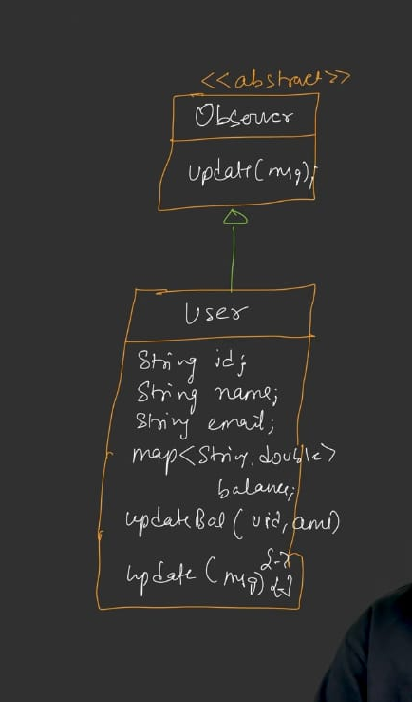

3. Split Class

Why Not Use Pair
- Pair<userId, amount> is confusing (.first / .second require remembering order)
- LL Design best practice: use a dedicated small class

Fields
text
Split
- userId: String
- amount: Double
- Represents "user X owes amount Y" for a specific expense

Relationship
- Expense has-a List<Split> (one-to-many)

4. Expense Class

Fields
Field | Type | Purpose
expenseId | String | Unique ID (e.g., "expense1")
description | String | What the expense was for
amount | double | Total amount paid
paidByUserId | String | Who paid
splits | List<Split> | Who owes what
groupId | String | Group this expense belongs to (null/empty if individual)

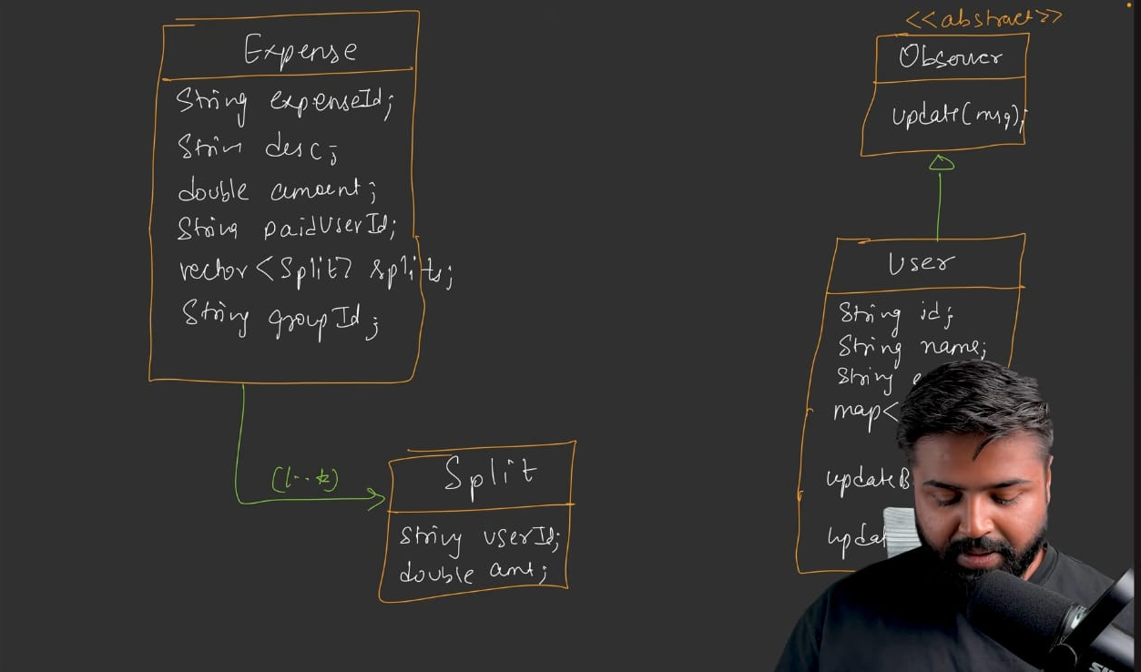

Group vs Individual
- Group expense: groupId = G1 (populated)
- Individual expense: groupId = null or empty

5. Split Strategies

Abstract SplitStrategy
text
SplitStrategy (abstract)
+ calculateSplit(totalAmount, List<String> userIds, List<Double> values) : List<Split>
- values is optional — used only by Percentage/Exact strategies
- Default empty list for Equal strategy

5.1 EqualSplitStrategy
- Input: total amount, user IDs
- Logic: perHead = totalAmount / userIds.size()
- Output: One Split(userId, perHead) per user
- Ignores the values parameter

5.2 ExactSplitStrategy (a.k.a. Unequal Split)
- Input: total amount, user IDs, exact values
- Logic: For each user, use the exact value from values[i]
- Output: Split(userId[i], values[i])
- Note: Client specifies exact amounts each user pays
- Validation to add: userIds.size() == values.size(); sum of values should equal total

5.3 PercentageSplitStrategy
- Input: total amount, user IDs, percentage values
- Logic: actualAmount = totalAmount * percentages[i] / 100
- Output: Split(userId[i], actualAmount)
- Validation to add: userIds.size() == values.size(); sum of percentages should be 100

Why Separate values and userIds (Not Vector of Pairs)
- Pairs are confusing externally (first/second semantic)
- Better to have parallel lists: List<String> userIds, List<Double> values
- Internally, use small classes (Split) — not raw Pairs
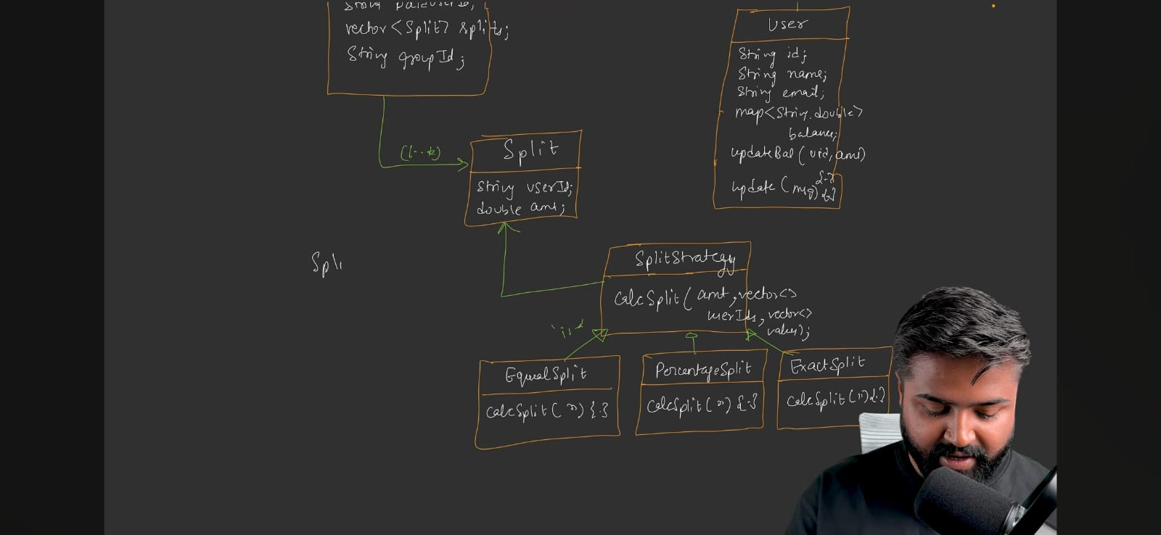

6. SplitFactory (Strategy Pattern)

Enum
text
SplitType { EQUAL, EXACT, PERCENTAGE }

Factory
text
SplitFactory
+ static getSplitStrategy(SplitType type) : SplitStrategy
- Returns:
  - EQUAL → EqualSplitStrategy
  - EXACT → ExactSplitStrategy
  - PERCENTAGE → PercentageSplitStrategy
  - Default (unknown type) → EqualSplitStrategy (fail-safe)

Why Static
- No state needed → static method is enough
- No need to instantiate → SplitFactory.getSplitStrategy(...) directly

Design Patterns Used
- Strategy Pattern — interchangeable algorithms
- Factory Pattern — creation of strategies by type
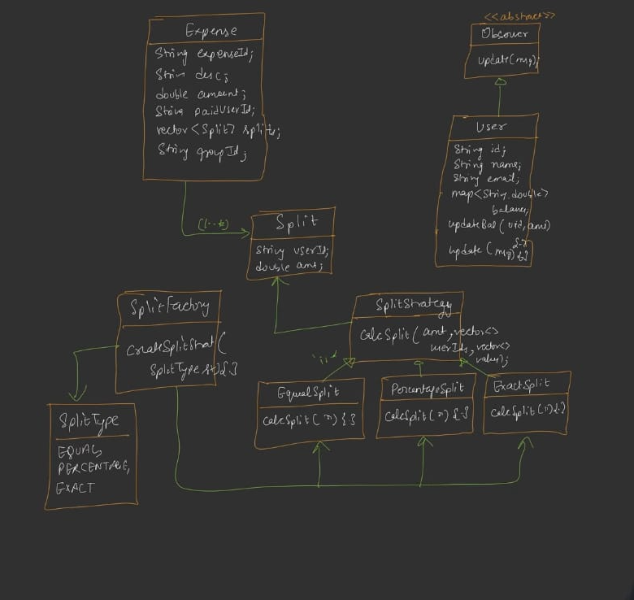

7. Group Class (Observable)

Why Group is Observable
- It knows when an expense is added or settled
- It's the source of truth for group-level events
- Notification must come from here

Design Choice
- Group implements Observable directly (rather than abstract Observable base class)
- Reason: There's only one observable (the Group) — no need for abstraction
- Trade-off: Breaks Single Responsibility Principle (Group has business logic + observer logic) — but acceptable trade-off in this context

Fields
Field | Type | Purpose
groupId | String | Unique group ID (e.g., "group1")
name | String | Group name
members | List<User> | All group members (they're also observers)
expenses | Map<String, Expense> | Expense ID → Expense (full history)
balances | Map<String, Map<String, Double>> | Nested map: member ID → (other member ID → amount)

Why Nested Map for Balances
- Group has many users; each user has their own balance sheet
- Structure: balanceSheet[userA][userB] = amount
  - Positive = userB owes userA
  - Negative = userA owes userB
- Single source of truth for all balance info within the group

Methods

Observer Methods
Method | Purpose
addMember(User user) | Add user to members list; initialize empty balance sheet for them (balances[userId] = new HashMap<>())
removeMember(userId) | Remove user (see canUserLeaveGroup check first); remove from members, balances, and from other members' balance sheets
notifyMembers(message) | Iterate members → call update(message) on each
isMember(userId) | Check membership

Private Helper
- getUserByUserId(userId) — iterate members to find user

Main Business Methods
Method | Purpose
addExpense(description, amount, paidByUserId, List<String> involvedUserIds, SplitType type, List<Double> values) | Main entry: validates, creates expense, updates balances, sends notification
settlePayment(fromUserId, toUserId, amount) | Record a settlement: call updateGroupBalance, notify
updateGroupBalance(fromUserId, toUserId, amount) | Core: update both users' balance entries (+amount for from, -amount for to in respective maps); remove zero entries
canUserLeaveGroup(userId) | Check if user has zero outstanding balance in the group
simplifyGroupDebt() | Run DeptSimplifier.simplify(balances) and update balances
showGroupBalances() | Print all members' balance sheets
getUserGroupBalance(userId) | Return the member's balance map

addExpense Flow (detailed)
- Validate:
  - paidByUserId is a member
  - All involvedUserIds are members
- Get splits via SplitFactory.getSplitStrategy(type).calculateSplit(amount, involvedUserIds, values)
- Create Expense(description, amount, paidByUserId, splits, groupId)
- Store in expenses[expenseId]
- Loop splits → for each split: call updateGroupBalance(paidByUserId, split.userId, split.amount) to update balances
- Notify members: notifyMembers("New expense added: " + description + " of amount " + amount + " by " + name)
- Print console summary (for demonstration)

settlePayment Flow
- Validate both fromUserId and toUserId are members
- Call updateGroupBalance(fromUserId, toUserId, amount) → reduce debt
- Notify members: "fromName paid toName amount"
- Print console summary

updateGroupBalance — The Core Math
java
balances.get(fromUserId).merge(toUserId, amount, Double::sum);
// In real code: fromUserBalance[toUser] += amount
balances.get(toUserId).merge(fromUserId, -amount, Double::sum);
// In real code: toUserBalance[fromUser] -= amount
- Positive balance (for fromUser) = they will receive money
- Negative balance (for fromUser) = they will pay money
- Cleanup: if balance becomes 0 (within 0.01 tolerance for doubles) → remove from map
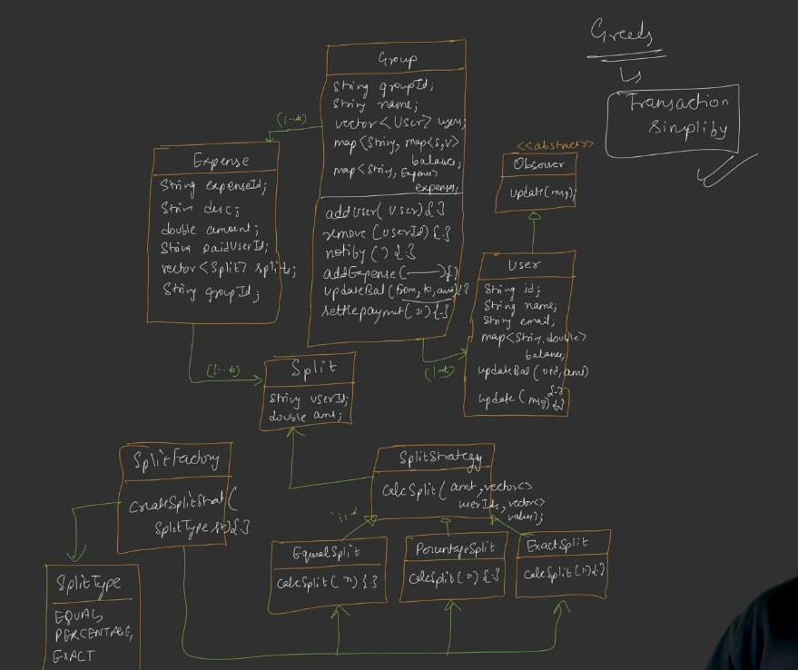

Why 0.01 Tolerance
- Doubles have precision issues
- If balance is 0.000001 → don't leave stale zero entries → remove with tolerance check

canUserLeaveGroup(userId)
- Check user is a member; if not → exception
- Get user's balance map
- Loop entries → if any abs(balance) > 0 → return false (has pending expenses)
- Otherwise return true

removeMember(userId)
- Call canUserLeaveGroup(userId) — if false, print error and return false
- Remove user from members list
- Remove balances[userId] entry (their balance sheet)
- For all other users' balance maps, remove userId entry
- Return true

8. DeptSimplifier — Transaction Simplification Algorithm

Purpose
Reduce the number of transactions needed to settle a group. Example:
- Before: A→B ₹200, B→C ₹200, A→C ₹200 (3 transactions)
- After simplification: A→C ₹400 (or similar minimal form)
- More complex chains → simplified to fewer transactions

Class Structure
text
DeptSimplifier
+ static simplify(balances: Map<String, Map<String, Double>>) : Map<String, Map<String, Double>>
- Static method — no state needed
- Input: full group balances map
- Output: simplified balances map

Core Algorithm — Greedy Approach
Step 1: Calculate Net Amount per User
- Initialize netAmount[userId] = 0 for all users
- Iterate over balances[userA][userB] = amount:
  - Only process positive amounts (to avoid double counting — every transaction is stored twice, once in A's map, once in B's)
  - If amount > 0:
    - netAmount[userA] += amount (A is creditor — should receive)
    - netAmount[userB] -= amount (B is debtor — should pay)
Step 2: Separate Debtors and Creditors
- Creditors: users with netAmount > 0 (should receive)
- Debtors: users with netAmount < 0 (should pay)
Step 3: Sort Both Lists
- Sort by amount (descending)
- Highest creditor first, highest debtor first
Step 4: Greedy Matching
- Match highest creditor with highest debtor
- Take min(creditorAmount, |debtorAmount|)
- Record transaction: debtor → creditor (this amount)
- Reduce both balances by matched amount
- If a balance hits zero → move to next in that list
- Continue until all settled

Worked Example (from Video)
Group: Hostel Expenses — Aditya, Rohit, Manish, Saurabh
Transaction 1: Aditya paid ₹800 for lunch — Equal split among all 4
- Each owes ₹200
- → Rohit→Aditya ₹200, Saurabh→Aditya ₹200, Manish→Aditya ₹200
Transaction 2: Manish paid ₹700 for dinner — Exact split among Aditya, Saurabh, Manish
- Aditya ₹200, Saurabh ₹200, Manish ₹300 (self)
- → Aditya→Manish ₹200, Saurabh→Manish ₹200
Net effect after both transactions:
- Aditya: +₹400
- Rohit: -₹200
- Manish: +₹200
- Saurabh: -₹400
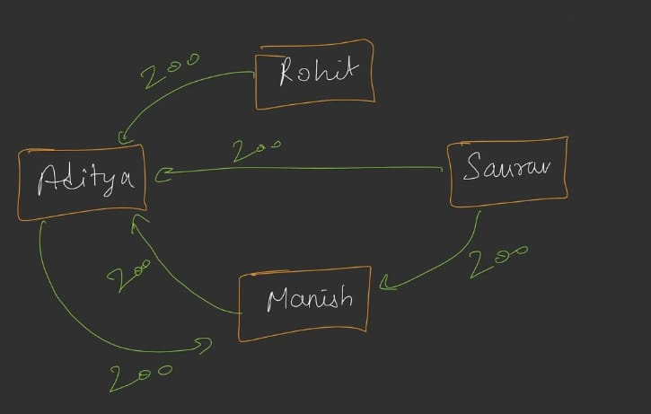
Naive settlement (3 transactions):
- Rohit→Aditya ₹200
- Saurabh→Aditya ₹200
- Saurabh→Manish ₹200
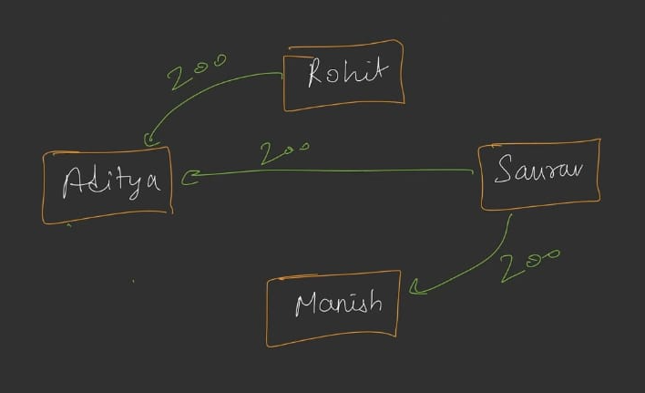
Simplified settlement (2 transactions):
- Saurabh→Aditya ₹400 (instead of ₹200 + ₹200)
- Rohit→Manish ₹200 (instead of Rohit→Aditya→Manish)

Greedy Matching Trace
- Creditors sorted: Aditya (+400), Manish (+200)
- Debtors sorted: Saurabh (-400), Rohit (-200)
- Match 1: Saurabh→Aditya ₹400 → both settle
- Match 2: Rohit→Manish ₹200 → both settle
- Result: 2 transactions (vs 3) — optimal
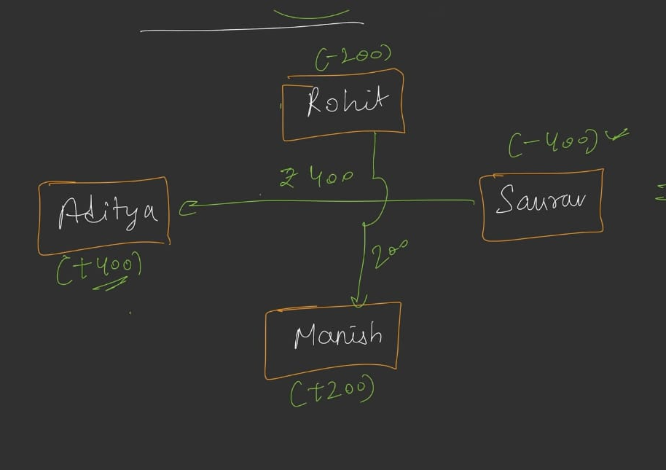

Data Structure Recommendation
- Use dedicated classes instead of Pair for clarity
- Separate lists for creditors/debtors
- Avoid exposing raw Pairs externally — only internal logic
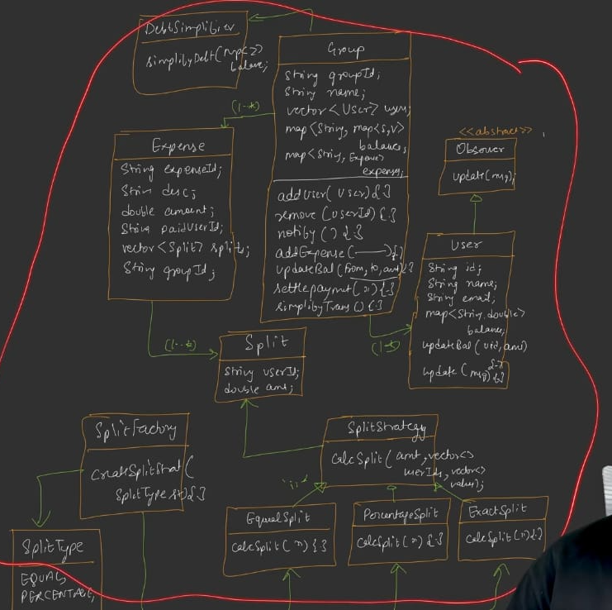

9. SplitWise Class (Facade/Orchestrator)

Purpose
Single entry point for the entire system — Facade pattern.

Design Patterns
- Facade: Simplifies complex subsystems (Group, User, Expense, SplitFactory, DeptSimplifier)
- Singleton: Only one SplitWise instance needed (private constructor, static instance)

Fields
Field | Type
users | Map<String, User> — userId → User
groups | Map<String, Group> — groupId → Group
expenses | Map<String, Expense> — expenseId → Expense (all expenses, group + individual)
instance | SplitWise (static, singleton)

User Management Methods
Method | Delegates to
createUser(name, email) | Create User, add to users map
getUser(userId) | Fetch from users map

Group Management Methods
Method | Delegates to
createGroup(name) | Create Group, add to groups map
getGroup(groupId) | Fetch from groups map
addUserToGroup(groupId, userId) | group.addMember(user)
removeUserFromGroup(groupId, userId) | group.removeMember(userId) — returns success/failure
addExpenseToGroup(groupId, ...) | group.addExpense(...)
settlePaymentInGroup(groupId, fromUserId, toUserId, amount) | group.settlePayment(...)
showGroupBalances(groupId) | group.showGroupBalances()
simplifyGroupDebt(groupId) | group.simplifyGroupDebt()

Individual Transaction Methods
Method | Purpose
addIndividualExpense(description, amount, paidByUserId, toUserId, type, values) | One-on-one expense — creates an Expense with groupId = null; updates both users' individual balances
settleIndividualPayment(fromUserId, toUserId, amount) | Update balances (both users), print/send notification

How Individual Expenses Work (since no Group)
- Get both users
- Calculate splits (usually 2-way)
- Create Expense (groupId = null)
- Add to global expenses map
- Update paidByUser.updateBalance(toUser, +amount) (paid user should receive)
- Update toUser.updateBalance(paidByUser, -amount) (owing user should pay)
- Print (and could add per-user notification via user-level observer)

showUserBalances(userId)
- Fetch user → iterate their balance map → print each (name, amount)
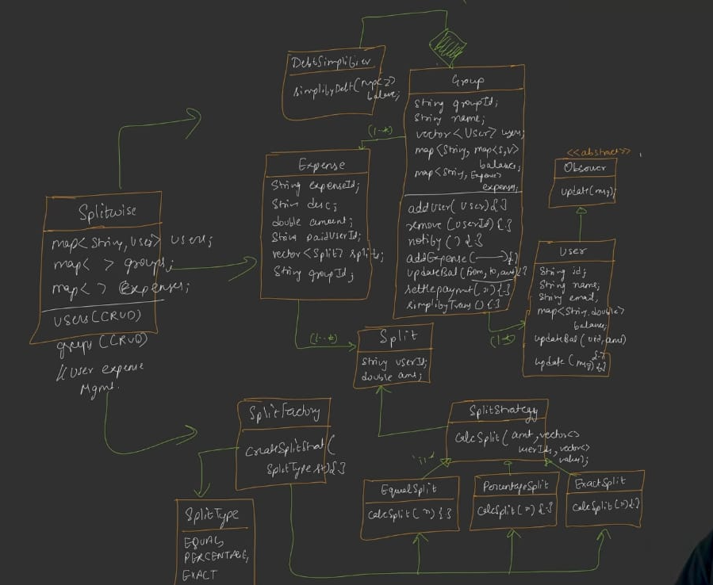
- Thread-safe lazy init (or eager static initialization)

10. Design Patterns Used
Pattern | Where | Purpose
Observer | User observes Group | Notifications on expense add/settle
Strategy | SplitStrategy (Equal/Exact/Percentage) | Interchangeable splitting algorithms
Factory | SplitFactory | Create strategies by type
Facade | SplitWise class | Single entry point for whole system
Singleton | SplitWise | One instance only
Template / Composition | Expense, Split | Small composable classes
Trade-off noted: Group as Observable breaks SRP (handles business logic + notification). Accepted trade-off — no other observable anticipated.
Why DeptSimplifier and SplitFactory are static (not Singleton):
- No state needed
- Static methods can be called directly via class name
- No benefit to Singleton here

11. Full UML Summary (Entities & Relationships)
text
SplitWise (Singleton, Facade)
├─ users: Map<String, User>
├─ groups: Map<String, Group>
└─ expenses: Map<String, Expense>

User (Observer)
├─ userId, name, email
└─ balances: Map<String, Double>

Group (Observable)
├─ groupId, name
├─ members: List<User> ← 1..*
├─ expenses: Map<String, Expense> ← 1..*
└─ balances: Map<String, Map<String, Double>>

Expense
├─ expenseId, description, amount
├─ paidByUserId: String
├─ groupId: String (null if individual)
└─ splits: List<Split> ← 1..*

Split
├─ userId: String
└─ amount: Double

SplitStrategy (abstract)
└─ calculateSplit(...) : List<Split>
├─ EqualSplitStrategy
├─ ExactSplitStrategy
└─ PercentageSplitStrategy

SplitFactory (static)
└─ getSplitStrategy(SplitType) : SplitStrategy

SplitType (Enum): EQUAL | EXACT | PERCENTAGE

DeptSimplifier (static)
└─ simplify(balances) : balances ← strong composition with Group
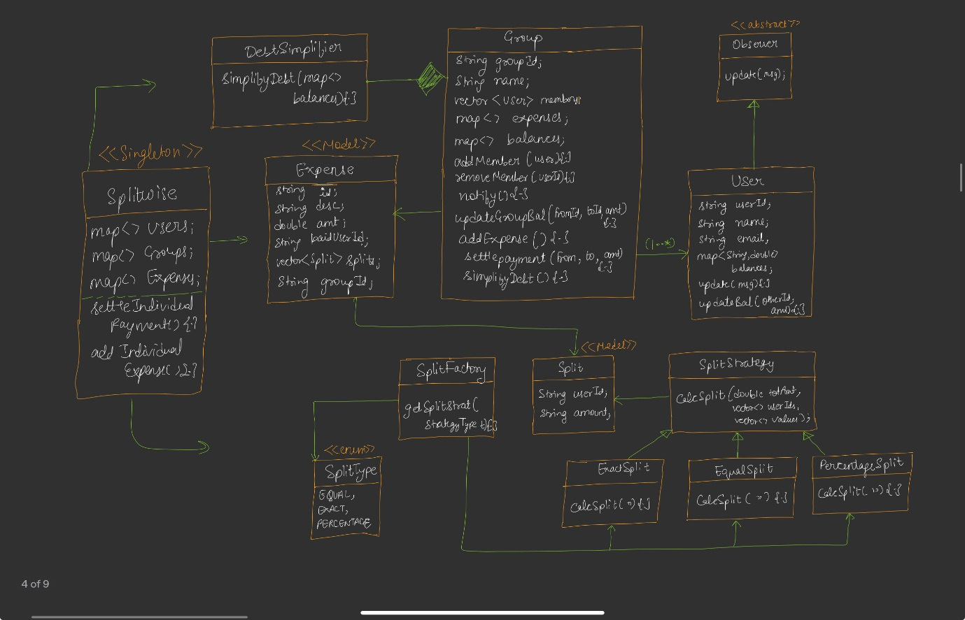
Composition relationship: Group strongly composes DeptSimplifier (only group uses it) — diamond operator in UML.

12. Main Flow (Demonstration)

Setup
- Create SplitWise (manager) instance
- Create 4 users: Aditya, Rohit, Manish, Saurabh
- Create "Hostel Expenses" group
- Add all 4 users to group

Two Group Expenses
Expense 1 (Lunch):
- Paid by: Aditya
- Amount: ₹800
- Involved: Aditya, Rohit, Manish, Saurabh
- Split: Equal
Expense 2 (Dinner):
- Paid by: Manish
- Amount: ₹700
- Involved: Aditya, Manish, Saurabh (Rohit excluded)
- Split: Exact → Aditya 200, Manish 300, Saurabh 200

Individual Transaction
Coffee:
- Paid by: Rohit
- Amount: ₹40
- For: Saurabh
- Split: Equal (₹20 each)

Interaction Sequence
- Show group balances (after both expenses)
- Run DeptSimplifier → simplify → show group balances again
- Add individual coffee transaction → show each user's individual balance
- Rohit tries to leave → blocked (₹200 owed to Manish in group)
- Rohit settles ₹200 to Manish → succeeds
- Rohit tries to leave again → succeeds
- Show final group balances (Rohit removed)

Expected Output (Sample)
- Notifications printed for each user (Aditya, Rohit, Manish, Saurabh) for each add/settle
- Group balance show: each member's owed/owing amounts
- After simplification: fewer transactions, same net effect
- Individual balance show: e.g., Saurabh owes Rohit ₹20 for coffee
- First leave attempt: "User not allowed to leave group without clearing expenses"
- After settlement: successful leave
- Final balances exclude Rohit; Aditya receives ₹400 from Saurabh; others zero
Code…..see notes

13. Key Interview Points
- Why Observer pattern: Decoupled notification delivery; group knows events, users react
- Why Strategy pattern: Splitting logic varies — makes it extensible
- Why Factory: Centralizes strategy creation; easy to add new strategy
- Why Facade: Client has one entry point; hides complexity
- Why Singleton for SplitWise: Only one instance needed (app-level state)
- Why DeptSimplifier is composition: Only group uses it; strong ownership
- Why not Pair: Confusing API (first/second), custom classes better
- Why Map<String, Map<String, Double>>: Represents each user's balance sheet within the group
- Why positive-only processing in DeptSimplifier: Every transaction stored twice; avoid double-counting
- Why 0.01 tolerance: Double precision issues; avoid stale near-zero entries
- Why user leave check: Business rule — user can't abandon unpaid debts
- Why groupId = null for individual expenses: Distinguishes group vs individual context

14. DeptSimplifier — Algorithm Pseudocode
text
function simplify(balances):
netAmount = {}
for each userId in balances.keys:
netAmount[userId] = 0

for each (userId, userBalances) in balances:
for each (otherUserId, amount) in userBalances:
if amount > 0: // process only positive
netAmount[userId] += amount
netAmount[otherUserId] -= amount

creditors = [(id, amt) for (id, amt) in netAmount if amt > 0]
debtors = [(id, -amt) for (id, amt) in netAmount if amt < 0]

sort creditors descending by amt
sort debtors descending by amt

i, j = 0, 0
simplified = {} // new balances map
while i < creditors.len and j < debtors.len:
settleAmt = min(creditors[i].amt, debtors[j].amt)
creditorId = creditors[i].id
debtorId = debtors[j].id

simplified[debtorId][creditorId] = -settleAmt
simplified[creditorId][debtorId] = +settleAmt

creditors[i].amt -= settleAmt
debtors[j].amt -= settleAmt
if creditors[i].amt == 0: i++
if debtors[j].amt == 0: j++

return simplified

15. Refinements / Extensions Suggested
- Individual notifications: Users could be Observables too (user A notifies user B of individual transactions) — extra complexity but doable
- Validation enhancements: Extend strategies with checks (sizes match, percentages sum to 100, exact values sum to total)
- UUID for IDs: Production-grade ID generation
- Persistence: Currently in-memory; would add DB in real app
- Zero-handling tolerance: 0.01 for double comparisons
- Circular dependency handling: Handled naturally by updateBalance symmetric updates

16. One-Line Summary per Class
Class | One-line Summary
Observer | Abstract interface with update(message)
User | Concrete observer; holds individual balance map; receives notifications
Split | Small POJO — userId + amount
Expense | Records paidBy, amount, description, list of splits, optional groupId
SplitStrategy | Abstract; calculateSplit(...)
EqualSplitStrategy | Divides amount equally
ExactSplitStrategy | Uses provided exact values
PercentageSplitStrategy | Multiplies total by percentage / 100
SplitFactory | Returns strategy for a SplitType enum
Group | Observable; manages members, expenses, nested balance map; main business logic
DeptSimplifier | Static; greedy algorithm to minimize transactions
SplitWise | Singleton + Facade; orchestrates users, groups, individual expenses

